Exp 7:- Design a Programmable Digital Data Display system

**Circuit Diagram:-** 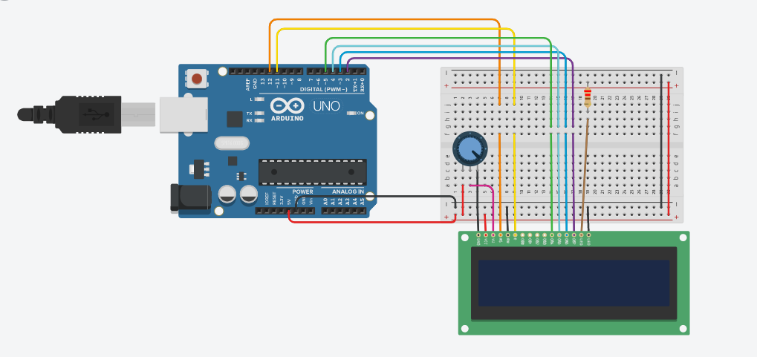

Theory: -

**Concept used:-**

* The Arduino board can supply a power of 5V as digital output signals through the 14 pins (namely 0-13) present in it as digital input or output pins.   The GND pin of the Arduino board acts as ground (It provide 0V).
* We need to enable the header file (‘#include <LiquidCrystal.h>’), this header file has instructions written in it, which enables the user to interface an LCD to UNO in 4 bit mode without any fuzz. With this header file we need not have to send data to LCD bit by bit, this will all be taken care of and we don’t have to write a program for sending data or a command to LCD bit by bit.
* Since we have so many different types of LCD (like 20x4, 16x2, 16x1 etc.). Here we are going to interface a 16x2 LCD to the UNO so we get to use the code ‘lcd.begin(16, 2)’;
* Potentiometer is used to provide variable resistance. A 'potentiometer' is typically used to implement a variable voltage divider which otherwise would require two resistors. In this case the potentiometer is used to provide a voltage at pin 3 that is used to adjust the contrast of the LCD.

Learning and Observation: -

**Learnings:**

* In 16x2 LCD there are 16 pins over all if there is a back light, if there is no back light there will be 14 pins.
* One can power or leave the back light pins. Now in the 14 pins there are 8 data pins (7-14 or D0-D7), 2 power supply pins (1&2 or VSS&VDD or GND&+5v)
* 3rd pin for contrast control (VEE-controls how thick the characters should be shown), and 3 control pins (RS&RW&E).
* A potentiometer is also used for calibration of resistance as to maintain the contrast of the screen.

**Observations:-**

* When the code is uploaded to the Arduino broad it worked accordingly i.e. the LCD turned on and “Hello World” is printed along with the counter.

Problem and Troubleshooting:-

* The code was not uploading to the Arduino because of the wrong port selection. Make sure to choose the correct port just after connecting Arduino with the PC.
* Problem in compilation due to syntax error. So make sure to write the correct code
* Problem in sketching i.e. code uploading due to problem in Arduino IDE. If this problem is encountered start the IDE again.
* Make sure negative terminal of the LED i.e. of LCD is connected to ground and vice-versa.
* Potentiometer is damaged. Use another potentiometer and check it via multimetre.

Precautions**:-**

* Make sure the circuit is closed
* The connections at different points should not be loose and the pins should be inserted properly.
* Make sure LCD is not damaged.
* Handle LCD with care and don’t bend the PINS of the LCD.

Learning Outcomes:-

•   I have learned how to use a LCD with arduino.

•   Through this experiment I have gained the skill of making a circuit using different hardware and controlling the functions done by that circuit with the help of codes.

•   I have learned how to display data on LCD.

•   Learned how to use a potentiometer and also learned about its working.

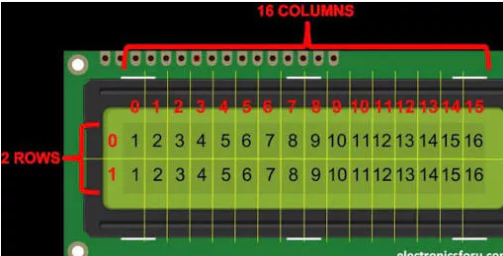

•   I have learned that 16x2 LCD will have 32 characters in total 16in 1st line and another 16 in 2nd line.

•   I also came to know, that in each character there are 5x10=50 pixels so to display one character all 50 pixels must work together. But we need not to worry about that because there is another controller (HD44780) in the display unit which does the job of controlling the pixels.